Title- Recruitment and training of employees in awadh sugar and energy limited

Submitted to partial fulfilment for the award of degree

“ Bachelor of Business Administration ( B.B.A.)”

2019-2020

Submitted to-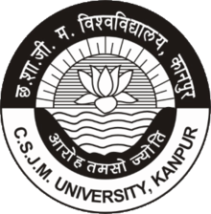

CHHATRAPATI SAHU JI MAHARAJ

UNIVERSITY, kANPUR

UNDER THE GUIDANCE OF

PROF. PRACHI SRIVASTAVA SUBMITTED BY- ANURADHA SINGH

B.B.A. 3rd year



Sacred heart degree college, naipalapur, Sitapur

Acknowledgement

I would like to extend my sincere thanks to Reverend father Joseph ponmany,principal,sacred heart degree college for equipping us with all possible resources and continuous motivation in my research work. It was a constant back up for us to produce quality work and contribute in the field of research. I express my profound sense of gratitude to my project supervisor Prof.Prachi srivastava (assistant professor Department of business administration, SHDC) for her valuable guidance and constant encouragement at every stage, which has enabled m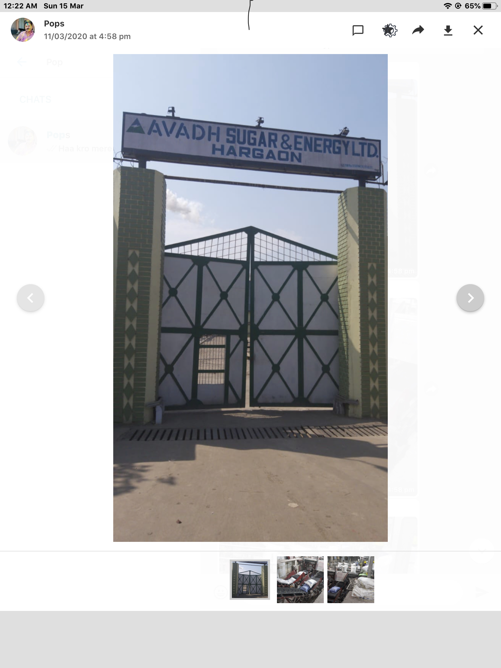e to complete this project. I am extremely grateful to her for spending a lot of hi precious time out of her busy schedule to discuss various facts this work,Without her kind supervision This work I have not been possible. I deem it my good fortune To have worked under Her able and export guidance.With sincere thanks I place on record my deep sense of guidance to them. I also wish to put my immense gratitude to all faculty Members of the Department of business administration who encouraged me and provided moral support for the completion of this thesis.

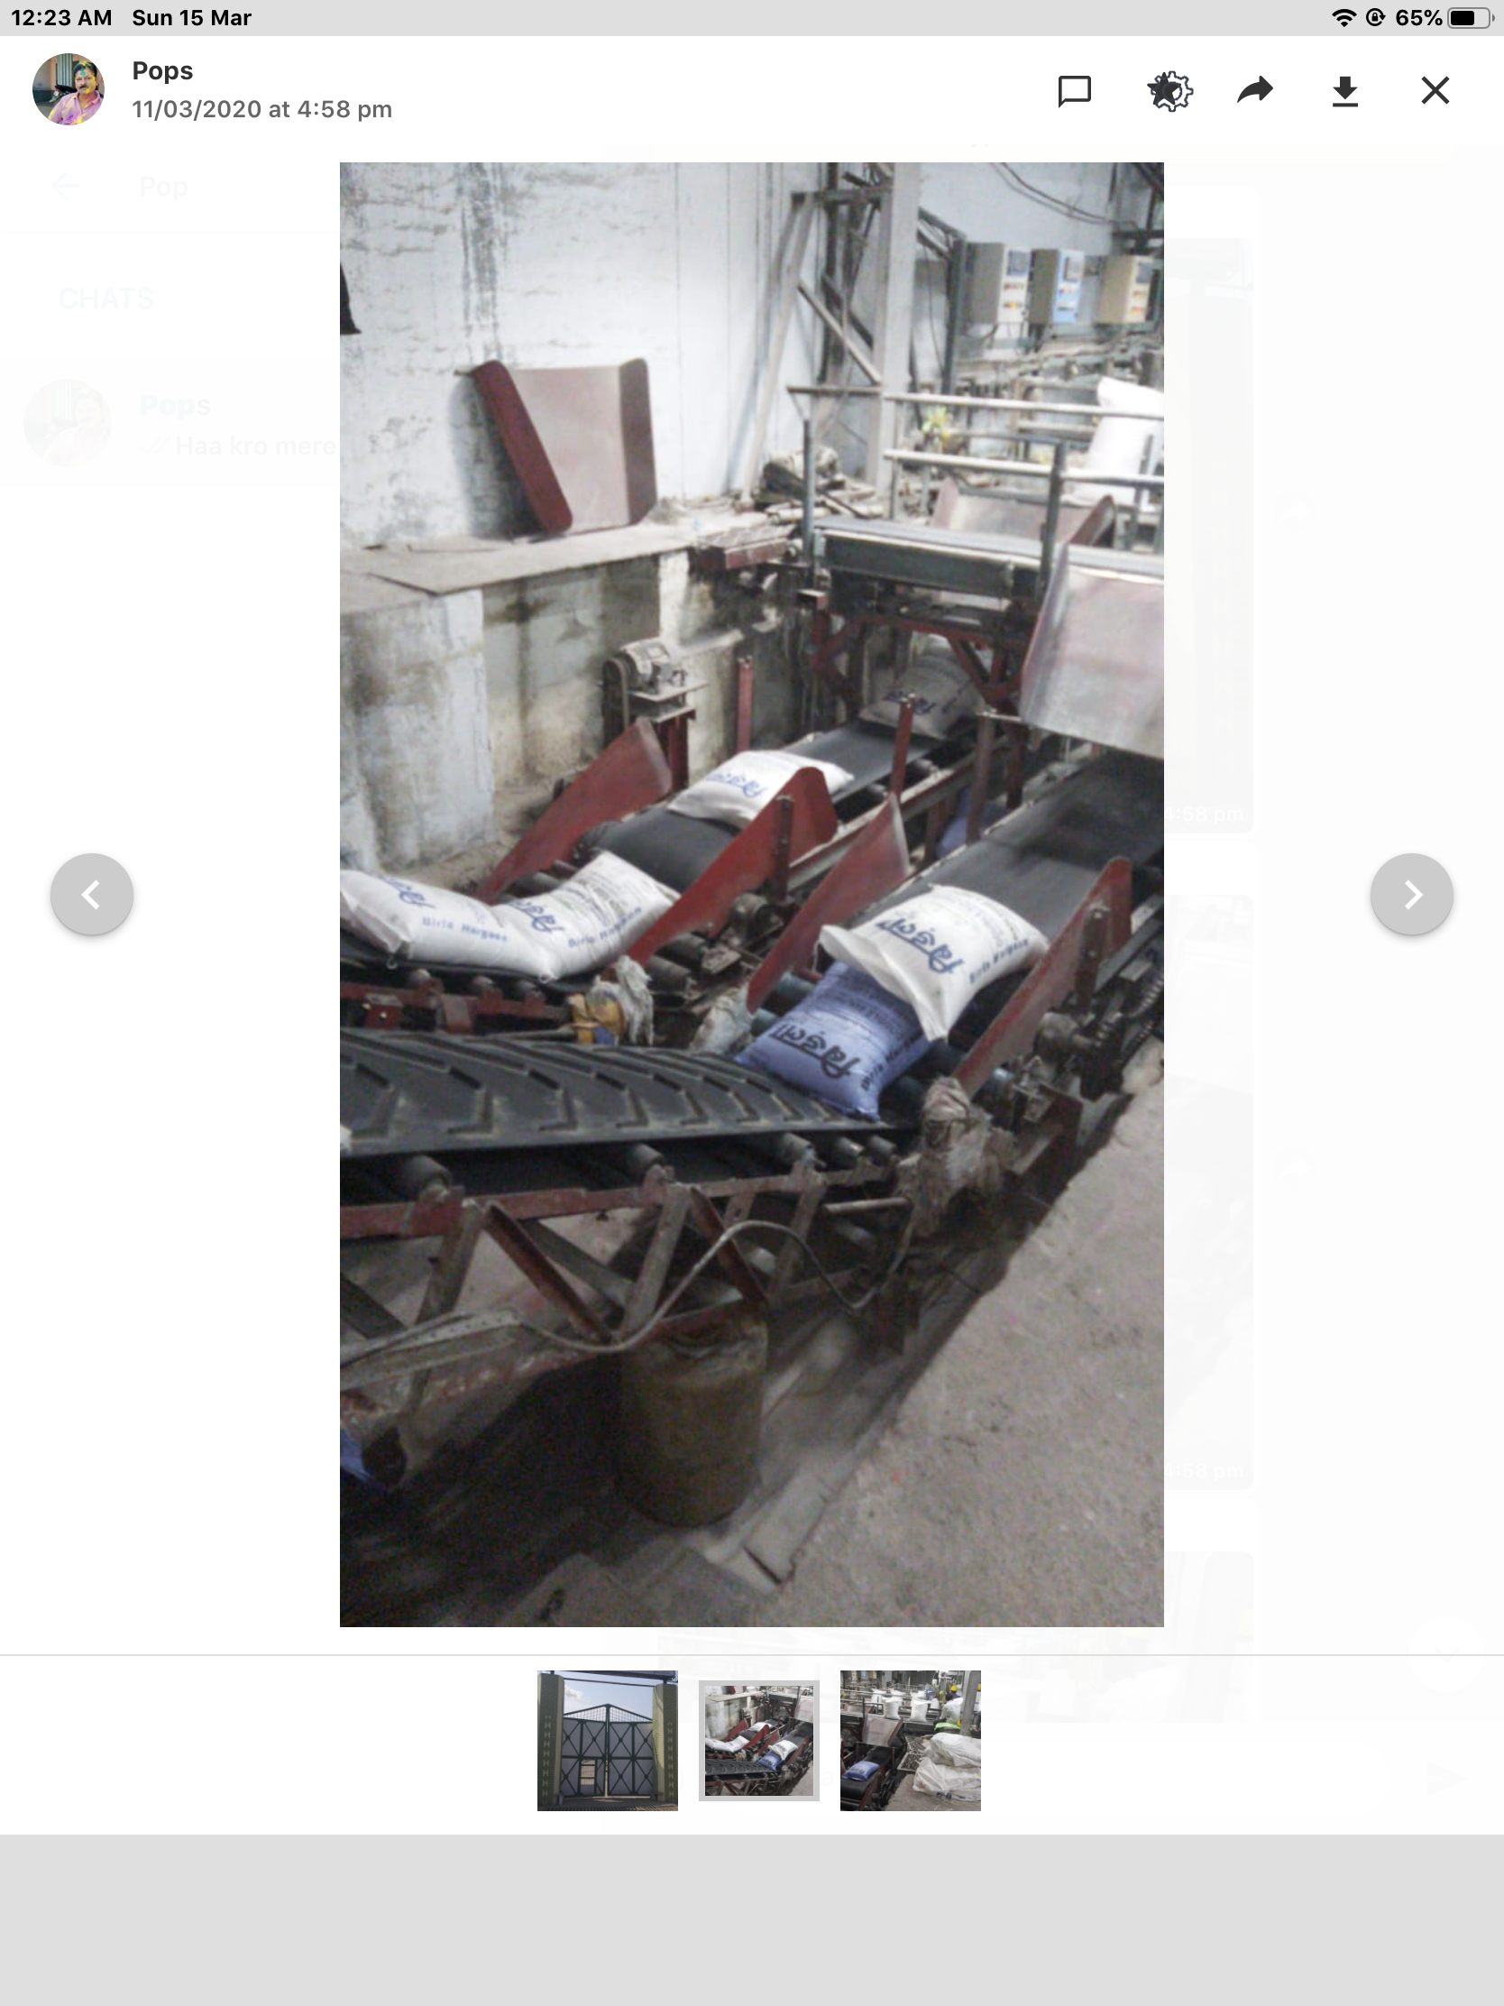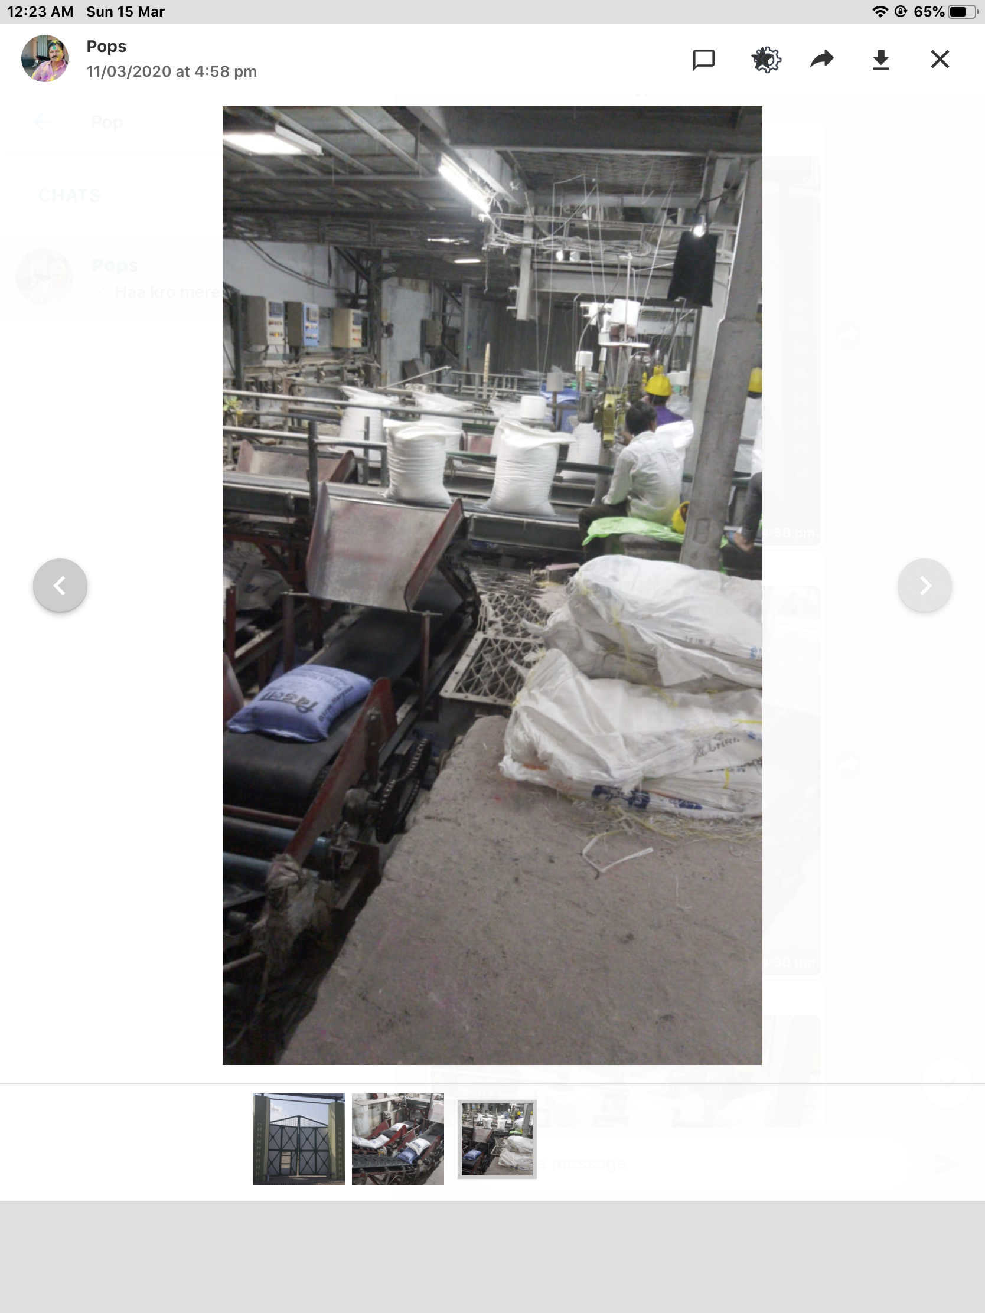

awadh sugar and energy limited

Declaration

I hear by declare that the project work entitled “ performance appraisal System at Awadh sugar and energy Ltd“ submitted to the Department of business administration, SHDC, is record of an original work done by me under the guidance of Prof. Prachi srivastava,(designation),And this project work is summitted in the partial or fulfilment of the requirements for the Award of the degree of “ Bachelor of business administration”. The results embodied in this Project have not been submitted to any other university or institute for the award of any degree or diploma.

Certificate

This is to certify,”Anuradha Singh, BBA-3rd Year” Has completed this project work entitled,”Performance appraisal system at awadh sugar Ltd” Under my supervision.To the best of my knowledge and belief this project work is original in nature and it is suitable for submission for the Award of bachelor of business Administration degree at the Sacred Heart degree College,Naipalapur.

Preface

It is a great Opportunity For me to join bachelor of business administration degree at Sacred Heart degree College, Sitapur, In the accomplishment of this degree, I am submitting My research project on”Performance appraisal system at Awadh sugar and energy Ltd”Subject to the limitation of time, effort and resources Every possible manner. The whole project is measured through questionnaire , Observation, feedback.The data further process and analysed in order To generalise The results. The whole project is broadly divided into following chapters; –

Introduction

Objective of research report

Research methodology

Data analysis

Limitations

Table of content

Introduction

**Training and development of employees in Human Resource Management**

What is Human Resource?

Human resource are knowledge, skills, creative abilities, talents and attitudes obtained in a population. Whereas from the point of the individual enterprise, they represent total of the inherent abilities acquired knowledge and skills as exemplified in the talent and attitude of the employees.

what is Human Resource management ?

HRM Refers to the application of principles of management to manage the people working in the organisation.

Training of employees in HRM

It is a learning process that involves the acquisition of knowledge, sharpening of skills, concepts, rules, or changing of attitudes and behaviours to enhance the performance of employees.

Training is activity leading to skilled behavior.

* It’s not what you want in life, but it knows how to reach it
* It’s not where you want to go, but it knows how to get there
* It’s not how high you want to rise, but it knows how to take off
* It may not be quite the outcome you were aiming for, but it will be an outcome
* It’s not what you dream of doing, but it’s having the knowledge to do it

• It's not a set of goals, but it’s more like a vision

• It’s not the goal you set, but it’s what you need to achieve it

Training is about knowing where you stand (no matter how good or bad the current situation looks) at present, and where you will be after some point of time.

Training is about the acquisition of knowledge, skills, and abilities through professional development.

Role of training

* **Optimum Utilization of Human Resources** – Training and Development helps in optimizing the utilization of human resource that further helps the employee to achieve the organizational goals as well as their individual goals.
* **Development of Human Resources** – Training and Development helps to provide an opportunity and broad structure for the development of human resources’ technical and behavioral skills in an organization. It also helps the employees in attaining personal growth.
* **Development of skills of employees** – Training and Development helps in increasing the job knowledge and skills of employees at each level. It helps to expand the horizons of human intellect and an overall personality of the employees.
* **Productivity** – Training and Development helps in increasing the productivity of the employees that helps the organization further to achieve its long-term goal.
* **Team work**– Training and Development helps in inculcating the sense of team work, team spirit, and inter-team collaborations. It helps in inculcating the zeal to learn within the employees.
* **Organization Culture** – Training and Development helps to develop and improve the organizational health culture and effectiveness. It helps in creating the learning culture within the organization.
* **Organization Climate** – Training and Development helps building the positive perception and feeling about the organization. The employees get these feelings from leaders, subordinates, and peers.
* **Quality** – Training and Development helps in improving upon the quality of work and work-life.
* **Healthy work** **spirit** – Training and Development helps in creating the healthy working environment. It helps to build good employee, relationship so that individual goals aligns with organizational goal.
* **Health and Safety** – Training and Development helps in improving the health and safety of the organization thus preventing obsolescence.
* **Morale** – Training and Development helps in improving the morale of the work force. • Image – Training and Development helps in creating a better corporate image.
* **Profitability** – Training and Development leads to improved profitability and more positive attitudes towards profit orientation.
* **Training and Development aids** in organizational development i.e. Organization gets more effective decision making and problem solving. It helps in understanding and carrying out organizational policies
* **Training and Development helps** in developing leadership skills, motivation, loyalty, better attitudes, and other aspects that successful workers and managers usually display.

**TRAINING AND DEVELOPMENT OBJECTIVES**

The principal objective of training and development division is to make sure the availability of a skilled and willing workforce to an organization. In addition to that, there are four other objectives:

Organisational

Individual

Societal

Functional

1.**Individual Objectives** – help employees in achieving their personal goals, which in turn, enhances the individual contribution to an organization.

2.**Organizational Objectives** – assist the organization with its primary objective by bringing individual effectiveness.

3.**Functional Objectives** – maintain the department’s contribution at a level suitable to the organization’s needs.

4.**Societal Objectives** – ensure that an organization is ethically and socially responsible to the needs and challenges of the society.

**IMPORTANCE OF TRAINING OBJECTIVES**

Training objective is one of the most important parts of training program. While some people think of training objective as a waste of valuable time. The counterargument here is that resources are always limited and the training objectives actually lead the design of training. It provides the clear guidelines and develops the training program in less time because objectives focus specifically on needs. It helps in adhering to a plan. Training objectives tell the trainee that what is expected out of him at the end of the training program. Training objectives are of great significance from a number of stakeholder perspectives:

1. Trainer

2. Trainee

3. Designer

4. Evaluator

**Trainer** – The training objective is also beneficial to trainer because it helps the trainer to measure the progress of trainees and make the required adjustments. Also, trainer comes in a position to establish a relationship between objectives and particular segments of training.

**Trainee** – The training objective is beneficial to the trainee because it helps in reducing the anxiety of the trainee up to some extent. Not knowing anything or going to a place which is unknown creates anxiety that can negatively affect learning. Therefore, it is important to keep the participants aware of the happenings, rather than keeping it surprise.

Secondly, it helps in increase in concentration, which is the crucial factor to make the training successful. The objectives create an image of the training program in trainee’s mind that actually helps in gaining attention. Thirdly, if the goal is set to be challenging and motivating, then the likelihood of achieving those goals is much higher than the situation in which no goal is set. Therefore, training objectives helps in increasing the probability that the participants will be successful in training.

**Designer** – The training objective is beneficial to the training designer because if the designer is aware what is to be achieved in the end then he’ll buy the training package according to that only. The training designer would then look for the training methods, training equipments, and training content accordingly to achieve those objectives. Furthermore, planning always helps in dealing effectively in an unexpected situation. Consider an example; the objective of one training program is to deal effectively with customers to increase the sales. Since the objective is known, the designer will design a training program that will include ways to improve the interpersonal skills, such as verbal and non verbal language, dealing in unexpected situation i.e. when there is a defect in a product or when a customer is angry.

Therefore, without any guidance, the training may not be designed appropriately.

**Evaluator** – It becomes easy for the training evaluator to measure the progress of the

trainees because the objectives define the expected performance of trainees. Training objective is an important to tool to judge the performance of participants.

**What is development of a employees**

Employee development is a process of working with employees to improve, enhance,refine and existing skills and to also develop newer one’s in support of the organisation’s and missions and goals.

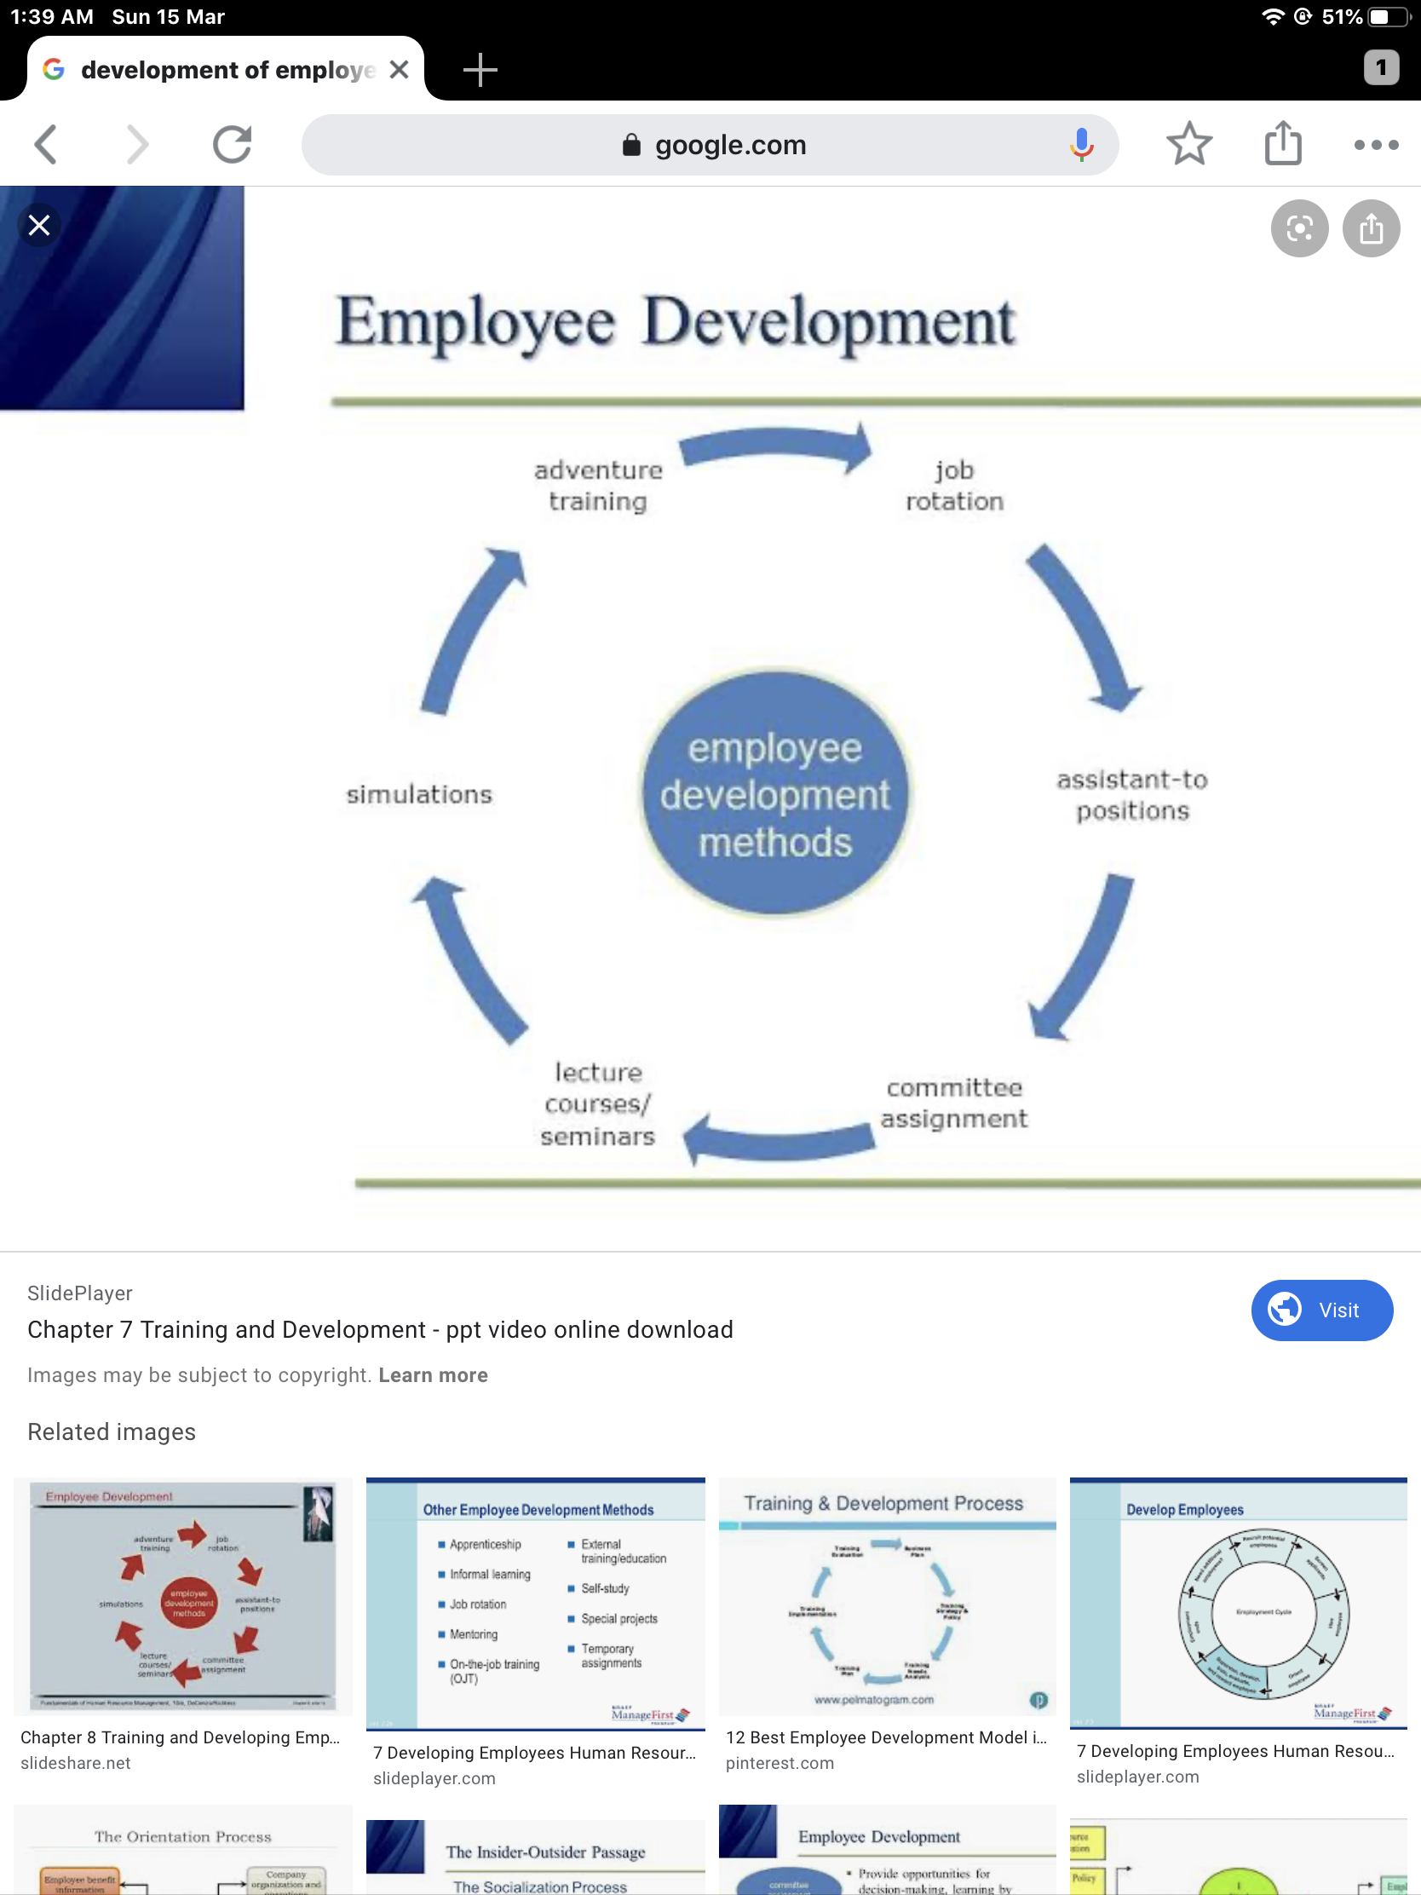

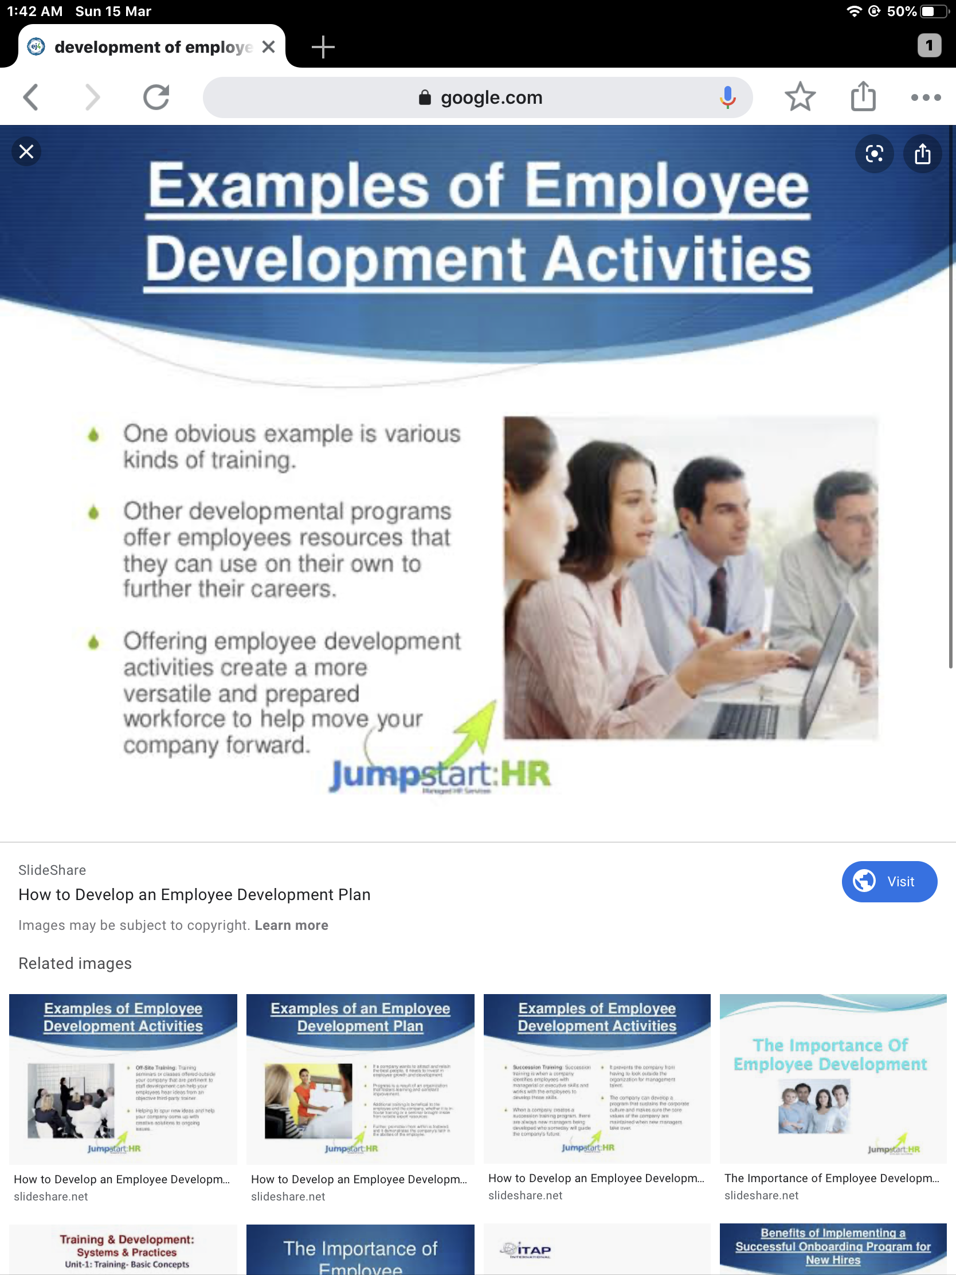

**ABOUT SUGAR INDUSTRY**

**INTRODUCTION**

Human Resources are the assests or wealth of the country that it can rely upon at anytime. The need of the hour is to develop these resources. The major challenge faced by Indian sugar industry is in the field of Human Resources Management. In order to involve the employees as active participants, HRM activities must be consistent with the development efforts of the organisation, only then, will be the enthusiasm and creative potential of the employees can be mobilized. The sugar industry has given HRM the opportunity to be more creative.

**Sugar industry an overview in INDIA**

India holds a very sweet position in the global sugar industry with the top slot for sugar consumption and the sugar production after Brazil. India produces 34,818,700 tons of sugar annually. Cultivation of sugarcane is the main source of sugar production in India and it is called sugar cane. 70% of sugar is produced from sugarcane and the remaining 30% of sugar comes from sugar beet.

Trade figures of India correspond to the mark of 1.5 million tons. The climate and soil condition in some parts of India are favourable for sugar cane cultivation. The sugar production upto 31st March ,2019 is 232 lakh tons. This is about 27.5 lakh tons higher than the production of 204.5 lakh tons last year, indicating an increase of 13% over last year. Uttar Pradesh has already produced 66.35 lakh tons up to the end of March 2019, U.P. alone accounts for 24% of the overall sugar production and Maharashtra’s contribution can be total led to 20%. There are about 599 sugar mills all over India.

In all, approximately Rs. 1250 crores are invested in this industry and it also provides livelihood for close to 2.86 lakh workers. The industry also benefits the nearly 2.5 crore people who grow sugarcane in India. In India, the major sugar producing states are Maharashtra, Gujarat, Uttar Pradesh, Haryana, Tamil Nadu, Punjab, Karnataka, Bihar and Andhra Pradesh. As may be seen from the list above, sugar production is practised all across India. However, the Peninsular region has been a better performer than the north Indian states and there has been a gradual shift from north to south from the sugar industry. One of the major reasons is the better conditions available for cultivation in the Penninsular part. The sugar industry in India is also highly localised owing to problems in transporting sugarcane.

**Types of sugar industry in India**

The sugar industry can be divided into two sectors including organised and unorganised sector. Sugar factories belong to the organised sector and those who produced traditional sweeteners fall into unorganised sector. Good and Khan sari are the traditional forms of sweetners.

**Manufacturing process of sugar in India**

Several steps are usually followed to produce sugar. These steps can be mentioned below :

1. Extracting juice by pressing sugarcane.
2. Boiling the juice to obtain crystals.
3. Creating raw sugar by spinning crystals in extractors.
4. Taking raw sugar to our refinery for the process of filtering and washing to discard remaining non-sugar elements and hue.
5. Crystallising and dry and sugar.
6. Package in the ready sugar.

**Sugar production in India**

In the 2014 to 15 crushing season, the sugar production of India has been seen an increase of 11.5%. The Indian Sugar Mills Association ISMA says that as of 31st March, India has produced 24,720,000 tonnes of sugar and this was an addition of 2,840,000 tonnes to the sugar production of 2013– 2015. It is estimated that in 2015 - 16 season, 24,800,000 tonnes of sugar will be consumed. I SM a estimates that due to the increased production in the year gone by, there will be a carryover stock of 8,500,000 tonnes. There will be 2,500,000 tonnes more than what is thought to be the standard requirement in these cases.

It is expected that in 2017, Indians will be consuming almost 28,500,000 tonnes of sugar. Maharashtra is traditionally the leader when it comes to the sugar production in India. Before Maharashtra, Uttar Pradesh was the leader. There were several reasons as to why Maharashtra occupy is this place in the pantheon of Indian states that produce sugar. The state has longer crushing period compare to the other states and its rate of recovery is also significantly higher.

Maharashtra currently has almost 25% of the sugar mills operating in India and it accounts For nearly 30% of the entire sugar produced in India. In fact, the sugar mills in Maharashtra are supposed to be the biggest in the country.Most of the sugar mills are located at the river valleys in the western stretches of the Maharashtra plateau. Ahmednagar is among the leading Centre of sugar production along with Kolhapur, Pune, Satara, Nashik And Solapur.

**Import and export of Indian Sugar industry**

The Indian government has rather a strict policy when it comes to import of sugar. During 2014, it has raised the time import duty from 15% to 40% with a view to discourage dark side of sugar trade and promote exports. Thanks to the increased import duty, refiners find it rather hard – economically unfeasible to be precise – to bring in sugar especially from countries such as Brazil, Pakistan and Thailand. The Indian government provides a subsidy amounting to Rs.4000 per tonne with the aim to promote exports.This is provided for raw sugar shipments, where the volume is around 1,400,000 tonnes. However, in spite of that, of late, Indian Sugar industry has had a hard time in exporting raw sugar owing to the fact that prices have been consistently on a downward spiral. The situation is specially precarious at the market in New York, which is regarded as a benchmark.

**Indian sugar industry consumption**

Consumption of sugar and related sweetness in India has increased in the last few years. One of the major reasons for the increasing demand for sugar is the growing population of India as well as improving economic condition. Majority of the consumers of the sugar that is produce directly by miss I’ll be crease, local sweets and candy manufacturers. Together with a soft drink makers, they comprise almost 60% of the clientele.The major consumers of Khan Sari are locally operating sweets establishments. Gur is also used in the rural areas In its normal form as a sweetener as well as feed. Biscuit Manufacturers, food product companies, pharmaceutical set ups, and hotels And restaurants also consume fair quantities of the sugar.

**Indian sugar industry consumption – impact on Indian economy**

As has been said already, almost 2.6,00,00 people are directly dependent on the sugar industry for their livelihood. Sugar industries and all agricultural industry that still provides the maximum amount of employment in India. The sugar industry in India also happens to be the second biggest Agro-based economic activity – a fact that goes on to show how important it is to sustain the national economy.

**Indian sugar industry – (Uttar Pradesh a leading producer)**

India has the largest consumer of sugar in the world and second largest producer of sugar. The industry has witnessed a shift in sugar production in the last few years. After registry and 8% increase in production in SS 2011–12, the sugar production for the last season showed a decline. As per current estimates the countries sugar production is around 243,00,00 tonnes for SS 2013–14. The major sugar producing states of India are Uttar Pradesh, Maharashtra, Karnataka, Gujarat, Tamil Nadu and Andhra Pradesh. The six states collectively contribute to more than 85% of India’s sugar production Uttar Pradesh and Maharashtra together contribute to more than 60% of India’s sugar production. The decline in production was primarily driven due to the Lower sugar production in Uttar Pradesh.

**Sugar cane crop and sugar demand and supply**

Sugarcane crop is a “ratoon crop”. The new crop is grown from the stable of the crop already harvested. So, the life of the crop planted is of multiple years, and generally new crop is not planted in the same farm area for few years.

There are three variants of sugarcane crop in India:

1.Spring crop sown in March.

2.Adsli crop sown in July.

3. Autumn crop sown in September.

Maturity time for a Adsali and spring crop is 18 months, Where as for autumn crop is 12 months. In India, the sugar season is from October – September. So sugar season 17 means October 16 to sept 17, with harvesting beginning in October 16. Total sugar cane crop production in India is~300 mn tons.

**By – products of sugar industry**

**Cogeneration**

One ton of sugar can produce 300 KG of bagasse which can be converted to 130 KWH of powerThe power generated by an integrated sugar mill is partially captivity consumed and remaining is exported. India’s sugar industry has potential to export 7500 MW power,And total installed, cogeneration capacity is all sugar mills is 4200 MW, Of which 3200 MW is being exported by sugar mills to the great. There are 60 mills in Uttar Pradesh with capacity of 1050 MWH.

**Ethanol**

Ethanol is a very key byproduct for integrated sugar mills. On an average, 10.8 of ethanol can be produced from one tonne of sugar. B – heavy molasses has better yield of ethanol (explain in detail later on in the article) Dan the molasses kindly use for ethanol production. Ethanol as blended in the fuel to reduce the dependence of the country on crude imports generally, and also ethanol is a cleaner fuel. ‘E20’ is a term to express 20% blending in the fuel.

India has 330 distilleries which can produce over 4 bn litres Of rectified spirit (alcohol) per year. Of these, 162 distilleries have the capacity to distil over 200 CR litres of conventional bioethanol. India produces conventional Bioethanol mostly from sugar molasses and partly from grains. Production of advanced bioethanol is still in the R & D stage. In UP there are 28 sugar mills which produces ethanol with capacity of 65.7 6CR litre in all over India.

**B heavy Molasses**

Ethanol also can be extracted via be having molasses routeTo get higher yield of ethanol per tonne of sugarcane. Conventionally, sugar is extracted in three stages, with very little sugar left to be extracted after the third stage. Left over after the third stage is the molasses, which has very little sugar content left, and this molasses is processed in a distillery for ethanol generation traditionally.

As per B Heavy molasses route, the sugar extraction Processor the stop after the second stage extraction and the molasses for second stage which are still rich in sugar content are used for extraction of ethanol. B heavy Molasses have ethanol yield of over 300 it per MT of molasses,Whereas the end of current molasses produced post to 230–250 it Per MT molasses.

Additionally, in the process leads to overall 2% reduction in recovery of sugar. This can serve two purposes 1.) blending of the fuel by more ethanol and 2.)conversion of extra sugar cane to ethanol rather than sugar which helps to solve the issue of oversupply of sugar during the years of overproduction of sugar cane.

As of now there is no policy in place to extract ethanol from B heavy route is not possible from Karen distilleries. However, minor Capex on existing distilleries would make them capable of extracting.

**Awadh sugar and energy limited**

AwadhSugar and energy Ltd, a part of the K.K. Birla group, is one of the India’s largest and fastest growing integrated sugar companies. It has a diverse product portfolio, comprising sugar, ethanol, power, organic fertilisers and food processing. Starting with a single Chal a manufacturing unit in 1932, they have now expanded their include food sugar manufacturing units, to distilleries and three co-Generation power plant, bio compost plant, and food and fruit processing unit. This evolution has been driven by their organic and inorganic growth models.

* It is the largest sugar producer in Sitapur district having crushing capacity of about 10,000 tonnes of sugarcane per day.
* Hargaon distillery capacity of producing 10K LPD of industrial ethanol.
* Hargaon cogeneration Power plant with a capacity of 50 MW power.
* Bio compost plant Organic fertiliser marketed under the brand name.

“**Awadh shakti jaivik khad”**

**Sugar mills of Birla group**

* Hargaon sugar mills, hargaon, Dist. Sitapur Uttar Pradesh with a crushing capacity of about 10,000 tonnes of sugar cane per day.
* Scohara sugar Mills, scohara, dist. Bijnor Uttar Pradesh with the crushing capacity of about 10,000 of sugar cane Per day.
* Rosa Sugar Works, Rosa District Shahjahanpur, Uttar Pradesh with a crushing capacity of about 4200 tonnes of sugar per day.
* New Indian Sugar Mills, hatta, District Kushinagar, Uttar Pradesh with a crushing capacity of about 7000 tonnes of sugar cane per day.

**Distilleries**

* Hargaon distillery, hargaon, District to Sitapur Uttar Pradesh with a capacity of producing hundred KLPD industrial/ethanol.
* Scchara distillery, scohara, District Bijnor Uttar Pradesh with a capacity of reducing hundred KLPD of industrial alcohol/Ethanol.

**Co-Generation power plants**

* Hargaon co-generation Power plant, hargaon, District Sitapur Uttar Pradesh the capacity of 15 MW power.
* Scohara co-generation Power plant, scohara, District Bijnor Uttar Pradesh with a capacity of 20 4MW power.
* Hata Power plant, district Kushinagar Uttar Pradesh with a capacity of 35 MW power.

**History of the company**

1932 Company was incorporated.

1933 Started business with commissioned are Sugar Mill hargaon district Sitapur in the state of Uttar Pradesh with a capacity of 400 TCD.

1945 Commissioning of the distillery to produce the industrial I’ll call at her hargaon.

1956 The equity shares of the company initially got listed on the stock exchange Bombay.

1976. The company purchased a sugar factory name to Roza Sugar Works act rules that district Shahjahanpur in the state of Uttar Pradesh with a crushing capacity of 1000 TCD.

1977 increased total crushing capacity to 2500 TCD at hargaon.

1984The company further expanded its network bike while another sugar complex named new Swadeshi Sugar Mills Ltd was merged with the company.

1987 hargaon Investment and trading Co Ltd and 0SM investment and trading Co Ltd but were incorporated on 26th December, 1986 under the companies act, 1956 and became subsidiary of the company.

1991 Increased total crushing capacity to 3500 TCD at hargaon.

1993 Increase total crushing capacity to 2500 TCD at NarkatiaGanj District West Champaran in the state of Bihar.

1996 Increased total crushing capacity to 5000TCD at hargaon, Highest by sugar industry standards.

1997 Increase the total crushing capacity to 2500 TCD at Rosa Sugar Works at Rosa district. Shahjahanpur in Uttar Pradesh.

1999 Increased total crushing capacity to 5000 TCS at NarkatiaGanj district West Champaran in the state of Bihar, highest of sugar industry standards.

2000 Commissioned a new buyer – compost plant with a capacity of 20,000 tonne per year at hargaon.

2001 In hand to crushing capacity to 4200 TCD add rose the district Shahjahanpur.

2003 To participate in the gasoline project initiated by the government for blending of 5% eaten all with petrol that it in all plant was commissioned with a capacity of 50 KLPD at NarkatiaGanj district West Champaran in the state of Bihar.

2004 Enhanced crushing capacity to 6500 TCV at her girl and achieve the highest Sugarcreek of re of 10.85% in the state of Uttar Pradesh.

2005 Enhanced crushing capacity to 7500 TCD out how to Gaya district commissioned a new bio-compost plant with a capacity of 13500 Tons Per year at NarkatiaGanj, district West Champaran in the state of Bihar.

2006 In has a crush on capacity to 10,000 TCD with complete automation for Sugar factory operations along with new 50 MW cogeneration plant at her go in hand to crushing capacity to 7500 TCD with complete automation for Sugar factory operations along with 10 MW co-generation plant Narkatiaganj, district West Champaran in the state of Bihar.

2007 The company achieved ISO 9001-2000 certificattion and ISO 14001-2004 certification.

2008 commissioned a most modern distillery of 100 KLPD capacity with Molecular sieve dehydration system.

2009 commissioned a new refined sugar plant at hata with a capacity of 7000 TCD

2010 commissioned a new co-generation plant at hata with A capacity of 20 MW at Hata dist. Khushinagar in the state of uttar pradesh.

Hargaon sugar unit achieved the third highest cane crushingin India by 152 lacs. Qtls.

2012 Enhanced crushing capacity to 8000 TCD at Hata Dist. khushinagar in the state of uttar pradesh.

**Directors of the organisation**

**Administrative department:**

* Chairman of the organisation – Mr. Chandrashekar Nopany
* Non-executive director – Mrs. Shalini Nopany
* Executive president/general manager ( G.M.)– Mr D.K.Sharma
* Human resource manager and A.G.M. -Mr Manoj Kukreti
* Chief financial Officer – Mr. Dilip Patodia
* Whole time director – Mr Chandra Bihari Patodia
* Vice president and secretary – Mr. Anand Sharma

**Human resource management of the organisation –**

* Current management resaws strength is 82
* Total employs of Birla Sugar Mills – 2149
* Total employs of Awadh sugar and energy Ltd – 538
* Employs ensure that house – up to 110

**Organisational structure –**Line and staff organisation are structure

**Working hours**– On the basis of shift.

**Products of the company**

-Sugar

-Molasses

-Bio compost

-Ethanol

-Power generation

**Sugar**

Sugar is produced at seven sugar mills of group spread across Uttar Pradesh and Bihar which together has the capacity to crush 46, 700 tonnes of sugar cane birthday. All the sugar factory is our equipped with the state of the art technology to produce pure white crystal cane sugar of the highest purity.

**About sugar cane**

Sugarcane is a perennial Grass in poaceae Family and is cultivated in tropical and sub – tropical regions for the sucrose that is found in its stems. It requires of roast – free climate with sufficient rainfall during the growing season to make full use of the plants great growth potential. The crop is harvested mechanically or by hand, chopped into lens and conveyed rapidly to the processing plant. Here it is either male and a juice extracted with water all the sugar is extracted by diffusion. The Jewish and then purified by time and heated to kill enzymes. The resulting is then concentrated in a series of evaporate hours and then further water is removed by way of evaporation losses in vacuum containers the resultingSuper saturated solution is seeded with sugar crystals and the sugar crystallises out and is separated from the fluid drive. The crystals of raw sugar have a sticky brown coat and can either be used as they are all can be a beast buy sell for dioxide or treated in carbonation passes to produce a whiter product product.

**Molasses**

Double acid generated in the Groups sugar factories are used as Raw Material in its distilleries for production of industrial alcohol/ethanol.

**About molasses**

Molasses, meaning honey like, that is a byproduct of sugar refining through repeated crystallisation of sugar syrup obtained by crushing sugarcane. Human consumption, to be used in baking and Intha brewing of ale, as for the industrial use. Less is used mainly in manufacture of industrial/potable alcohol ,yeast and cattle feed. Alcohol in turn is used to produce the north, rectified spirit and various value added chemicals. It annoying is consumed by chemical industry and is also used in blending of petroleum hi BP. In the range of 4.5% and 5%. Molasses and industrial alcohol – based industries were the controlled in 1993 and I love being controlled by the state policies. Nearly 90% of molasses whose is consumed by industrial alcohol manufacturers and remaining 10% of various other uses like potable liquor.

**Industrial alcohol and ethanol**

The group has in all three distilleries across with that Pradesh and to distilleries in Bihar I am the aggregate installed capacity of this unit is to 60 kilo litres per day.

**About industrial alcohol and ethanol**

Ethanol, A type of industrial alcohol, also Called Ethyl alcohol, Pure alcohol, grain alcohol, or drinking alcohol, is a volatile,Play Babel, coloured less liquid that Derived directly from molasses. Ethanol fuel is the most common biofuel worldwide, particularly in Brazil. Alcohol fuelled are produced by fermentation of sugar is derived from wheat, corn,Sugar beet, sugar cane, molasses and any sugar or starch that alcoholic fever ages can mean from like a potato and food waste etc. That it in all reduction method used our enzyme digestions to release sugars from store to store chains, foundation relation and right. Distillation process requires the significant energy for ethanol for heat ethanol can be used in petrol engines as a replacement for gasoline; it can be mixed with gasoline to any percentage . Most existing car petrol engines can run on blends of up to 15% bioethanol with petroleum/gasoline. Ethanol is also used to fuel bioethanol fireplaces. As they do not require a chimney and are “flue less”, bio ethanol fires are extremely useful for new build homes apartments without a flu.

**Beggasse and co- generation of power**

The group has six power Plant, 3 in U.P. and 3 in bihar with combined capacity to produce 112 MW of power. Baggasse is a fibrous matter that remains after sugarcane or sorghum stalks are crushed to extract their juice and is a by product generated in the process of manufacture of sugar. It can either be sold or be actively consumed for generation of steam. It is currently used as a biofuel and in the manufacture of pulp and paper products and building materials. The bagasse produced in a sugar factory is however used for generation of steam which in turn is used as a fuel source and the surplus generation is exported to the power grids of the state government.

For each 10 tonnes of sugarcane crushed, a sugar factory produces nearly 3 tonnes of wet begasse. Since begasse is a by- product Of the sugar cane industry,The quantity of production in the country is in line with the quantity of sugar cane produced.

Bagasse when burned in quantity produces sufficient heat energy to supply all the needs of a typical sugar mill, with enough energy to spare. To this end, a secondary use for this waste product is in cogeneration, the use of a fuel source to provide both heat energy, used in the mill and the electricity which is typically sold on the consumer through power grids.

The power-produced through co-generation substitutes the conventional thermal alternatives and reduces greenhouse gas emissions. In India, interest is high- efficiency bagasse-based cogeneration started in the 1980’s when electricity supply started falling short of demand. High-Efficiency bagasse cogeneration was perceived as an attractive technology both in terms of its potential to produce carbon neutral electricity as well as its economic benefits to the sugar sector. In the present scenario, where fossil fuel prices are shooting up and there is a shortage and non-availability of coal, co-generation appears to be a promising development. The thrust on distributed generation and increasing awareness for cutting greenhouse gas emissions increases the need for cogeneration. Also, it helps in controlling pollution from fossil fuels.

**Bio-compost**

Spent wash, an effluent generated from processed molasses is used with press mud for the production of organic fertlizer. The group has installed bio-compost plants at shyamalam near seohara, Narkatiaganj and hargaon to produce organic fertilizer which is marketed under the brand name “ uttam jaivik khad”, and “ oudh shakti jaivik khad”.

**Organisational structure**

**The Awadh sugar and energy limited is broadly divided into two parts:**

1. Mills
2. Administration

**Mills part divided into 10 parts:**

1. Production
2. Electrical
3. Mechanical
4. Sugar cane crushing machine
5. Utility
6. Stores
7. Quantity
8. Personnel
9. Co-ordinate
10. Sugar go down

**The administration part is divided into four divisions:**

1. Administration
2. Accounts
3. Marketing
4. Purchasing

The factory part is kept under the control of Deputy manager four works,To his absence it is under the control of the in charge President of the factory all the factory chief executive. The administration part is kept under control of the executive ( administration ) in case of this absence it is under the control of managing director.

**Work of company beyond profit**

Birla Sugar looks upon the welfare and all around the growth of its work and people staying close to it smells and factory is not simply as a responsibility but as a way of life. Organisations growth has always served as a tools to enrich society. The group continues to remain actively involved in the areas of education, medical, cultural and religious support and guidance to its employees and local area people as a part of the value chain. The group strongly believes that what is good for the society is good for the business. The initiatives of both the companies in the group can be summed up as follows –

the company has invested substantially in providing functional and behavioural training to enhance the competence of their employees.

* Free books are provided to poor children. It also provides free supply of medicines and other emergency equipments to the needy and underprivileged.
* An inter-11 college is run by the company.
* Regular health check up camps are organised at each of the plants. Religious functions are held from time to time at all plants.
* The company provides indirect imply meant in the state of Bihar and Uttar Pradesh to an estimated 10,000 people. As a contribution to maintain the environment green in at around the plant, saplings have been planted in factories and find area attached to the plant are developed in an organised manner and with a view to revolutionise the green concept.
* It has also set up numerous health care centres and hospitals in the vicinity of the plants. It also provides free supply of medicines and another emergency kit means to the needy and underprivileged.

**Objective**

**Objectives of the study**

* To study the need and importance of data training and development.
* To portray the profile of how much sugar and energy Ltd.
* To study the implementation of training and development in about Sugar Mill.
* To make data analysis and interpretation based on the perception of the employee in the organisation.
* To summarize and find certain suggestions for the importance of training and development system in company.

**Research Methodology**

**Introduction :**

The present study was undertaken to asses the method of training and development system in Awadh sugar and energy limited. This chapter explains the methodology, importance, purpose, objective and limitation of study. The psycho-social approach to the problem of training and development of Employees in the organisation has widened that scope of training and development research as it calls for the study of the training and development system in the organisation from which the various variables originate. A substantial number of Studies have been reported about the training and development under normal as well as isolated working on it. It is the best tablet that the competency required for different occupations/jobs vary not only in nature but in terms of content of performance. I review of training in development research clearly reveals that most of the research in this area has concentrated only on industrial and commercial organisations specially in the normal work environment. Training and development is a global phenomena affecting all professions and certain categories of employees. It is often assumed that employs in certain industries based on their nature of work required more amount of training and development. Training and development is one of the most deliberating personal and organisational problems of modern globe. Challenges posed by the changing business scenario have imposed employees to perform the task under a very compelling situation. Training and development has become an inevitable part of human life in recent times in what ever in the nature of job. It makes life more challenging and charming if it is excellent. However, when performance is below the ability of a person, it causes disturbances in his/ her life sphere. Training and development as a concept, it is naturally occurring which may have beneficial or destructive consequences, depending upon how it is managed. There have been many incidents, where poor performance has led to destructive consequences and vice versa; especially among the employees in industries, it has been found necessary to carry out this study. This study aims at throwing light on the process of training and development and how it can be effectively managed. Hence managing the process of training and development has become a subject of prime importance. Better management related to training and development leads to a happy and efficient work force.

**Purpose of the study:**

The purpose of the research was to evaluate the qualitative and quantitative functioning of the training and development system adopted in sugar mill. This study is chosen for an in-depth analysis and understanding of training and development system. It is the most universally accepted system for sustained performance and for The development in the organisation which is not only for growth but even for survival. It was planned because training and development is the only two which guides management to provide the needs of employs and extend facilities for the optimum utilisation of resources in the organisation. The lack of information on training and development system would increase the negative influence on understanding The objective of the organisation. Wind of liberalisation, privatisation in 1990 virtual training and development system focused on the traditional method all conventional method of evaluating subordinate by superiors in the organisation. However, that changed in the early 1990s, training and development system aims to measure industrial needs aspirations and requirements. Capability relation to his/it aims to foster team every group or organisational unit.The training and development system has to bring a total harmony between the individual performance and the organisational objectives.” Of any training and development system must be the improvement of the performance of the organisation and a sense of achievement and asking price. Despite this must be the most dominant feature in the design training in development system. Achieve this training in development system must create a appropriate environment, adequate opportunities and suitable incentives which Will provide the necessary encouragement to the individuals to see in walled in the station, which improves performance. Good performance of employs is required of the right type of managerial policies to have any impact on the performance. Therefore, the researcher is trying to suggest some of the remedial measures based on his study and provide insights into the system that need to be brought out in the industrial scenario. The present study aims to draw attention of 86 point involved in the system to identify the areas of improvement in the system.

**Methodology of the study**

After the objective of the study has Clearly stated , The next step is in for my research what is to determine The source from which the data is required to be collected. The data collection is an interesting aspect of the study achieving date I said delete the information consists of two types of data. The diagram is as follows:

**Primary data:**

The primary data are those, which are collected freshly and for the first time, from the employs directly. It is connected to the following methods –

**1.Questionnaire:** A structure of questionnaire was prepared and disturbed among the employees and workers.

**2.Interview:** Personal interviews and interaction with employees and contractor labour.

**3.Observation:** By observing the working environment.

**A.) Secondary data:**

The secondary data are those which have already been collected by someone which have been passed through statistical process. Sources of data can be categorised into two broad categories named published and unpublished statistics. Various sources are available namely books, synergies monthly (Chakravahini), C.R. Kothari , Research Methodology, Vishwas Prakashan books etc. and also collected from various files, records and synergies casting ltd.

**SAMPLE SIZE**

A sample of 80 employees has been selected. Although it looks to be a small sample keeping in view the large number of employees it has to be limited because of time constraints (6 weeks). Even then the sample size is not considered to be small. It is enough to draw conclusions.

**TYPE**

Since employees from all levels namely the top level, the middle level, and the lower level are bound to experience is just, the sample has to including lawyers from all levels. Stratified random sampling technique was selected by preparing questionnaire as this was the only technique that helped to draw conclusions accurately.

**NEED FOR THE STUDY**

Training and development of individuals, groups and organisations is a common practice of all societies. In social interactions, performance is conducted a systematic and planned manner to achieve widespread Popularity in recent years. Performance apprise it is essential to understand and improve the employee’s performance through HRD. In fact, performance appraisal is the basis for HRD. It was viewed performance appraisal was useful to decide upon employee transfer salary determination and the like. But the recent developments in human resource management indicate that performance appraisal is the basis For employed development. Performance appraisal indicate the level of desired performance level, level of actual performance and the gap between these two. This gap should be bridged through Human Resource Development techniques like training executive development etc.According to the Past survey it was noticed that the performance appraisal system in this company was not up to the mark. Hence there would be score for giving few suggestions as per my knowledge improve the performance appraisal the system which was Quite Essential For the better performance of the employees.

Importance of the study

Performance appraisals Provide employees and managers with opportunities to discuss areas in which employs Excel And those in which employs need improvement. Performance appraisals Should be conducted on a Regular basis , And they need to not to be directly attached to promotion opportunities.

Personal attention

During a performance appraisal review, a supervisor and unemployed discuss the employs strength And weakness. This gives the employee individual face time with the supervisor And a chance to address personal concerns.

Feedback

Employs need to know when their job duties are being fulfilled and when there are issues with their work performance. Manager should schedule this communication on regular basis .

Career path

Performance appraisal allow employees and supervisors to discuss goals that must be met to Advance with in the company. This can include identifying Skills That must be acquired, areas in which one must improve, and educational courses that must be completed .

Employee accountability

When employs know there will be regularly scheduled evaluations, They realise that they are accountable for their job performance.

Communicate Divisional and company goals

Besides communicating employs individual goals, employee Appraisals Provide the Opportunity For managers to explain organisational goals and the way in which employees can participate in the achievement of those goals.

DATA ANALYSIS

AND

INTERPRETATION

**Survey findings**

Findings

* + More than half of the employees (72.5%) agree that performance appraisal is the assessment of individual potential.
  + Some of the employees (30%) neutral that Performance appraisal system followed in the organisation is rational and fair .
  + Some Of The employees in (25%)Neutral that Job expectations are informed and the superiors set the tasks.
  + Most of the employees (67.5%) agree that Performance Appraisal followed in the Organization helps to the Training and development needs of employee.
  + Some of the employees (5%) disagrees that the Performance Appraisal in the organization help to recognize the competence of an individual.
  + Less than half of the employees (35%) disagrees that they are happy with the assessment of performance followed in the organization.
  + Most of the employees (30%) disagrees that Advises and suggestion are given to the employees during the appraisal process.
  + Most of the employees (37.5%) uninteresting accept the appraisal feedback.
  + Most of the employees (62.7%) feel the appraisal should be given by HOD.
  + Most of the employees (52.5%) that they need to be assessed as once in a year.
  + All most of the employees (95%) feels that the performance appraisal followed in the organization makes the employees motivated.
  + Most of the employees (40%) think that attitudes have impact on performance rating in the Organization .
  + Most of the employees (52.5%) do not agree that Performance is communicated after assessment of the Performance

Limitation

LIMITATIONS of the study

AsThe study Revolves around the performance appraisal Of human resources aspect The overall organisation performance cannot be ascertained . In Spite of giving honest and sincere efforts there are several limitations , Which are as follow:

The period of study is only about 46 day, Which is the Major constraint.

The preception bias Attitude of the respondens May Also act hurdles Two the study.

The study is only confined to performance appraisal.

The study cannot be orintedWith all HRM practising followed by Awadh Sugar Mills Ltd.Because of the paucity half Time requirements.

The sample size take care for the research it is more due to the constraint of time .

Suggestion

Suggestions

As per the study following are the suggestions:

* The training and development in the organisation should be in a full fledge way so that the others will be accepting this.
* As training and development is helpful to the employees by assignment of superior’s task but training in development which should be more affective so that the other employs will also be attracted.
* The training in development of the employer should be assisting affectively to the employs as it recognises the competence and potential of an individual.
* Employee’s training and development should be Philly don’t according to company’s policy so that it will assist the performance of the employees.
* The company should give some advices and suggestion to the employees during the process and should get their feedbacks about the process.
* The employees should be assess and appraised by their HOD once in a year.
* The employees should be aware of 360 degree appraisal and the organisation should follow this to motivate the employees.

**BIBLOGRAPHY**

**BIBLOGRAPHY**

**Books :**

* P.Subba Rao ,2006, Essentials of Human Resource management and Industrial Relations , Himalaya Publishing House .
* C.R.Kothri ,Research Methodology, Vishwas Prakashan
* Richard Rudman ,2003,Performance Planning and Review

**Journals:**

* + Gitam Journal of Management.
  + Indian Journal of Social Work.
  + Indian Journal of Human Resource.

**ANNEXURE**

**ANNEXURE**

**QUESTIONNAIRES**

NAME:_______

OCCUPATION:________

EDUCATION:_________

GENDER:________

SALARY RANGE:

**A.**Up to 2000

**B.**20000-40000

**C.** 40000-60000

**D.** Above 60000

**1.**Training and Development is the assessment of individual potential

1)Strongly Agree

2)Neutral

3)Strongly Disagree

4)Agreee

5)Disagree

**2. Training and development system flowed in the organization is rational and fair.**

1.Strongly

2.Neutral

3.Strongly disagree

4.Agree

5.Disagree

**3.Job expectations are informed and the superiors set the tasks.**

1.Strongly

2.Neutral

3.Strongly disagree

4.Agree

5.Disagree

**4. Is there any reward or awards given to those employes whose training and development is above the average in your factory?**

1.YES

2.NO

**5**